Toner RC Circuit

Abstract :
This Project is to implemented to adjust the frequencies using RC circuit that is achieved with input and output.
Components used:
1. Speaker
2. 3.5 mm jack.
3. Mobile phone.
4. 4ohm 10W speaker.
Circuit Diagram:
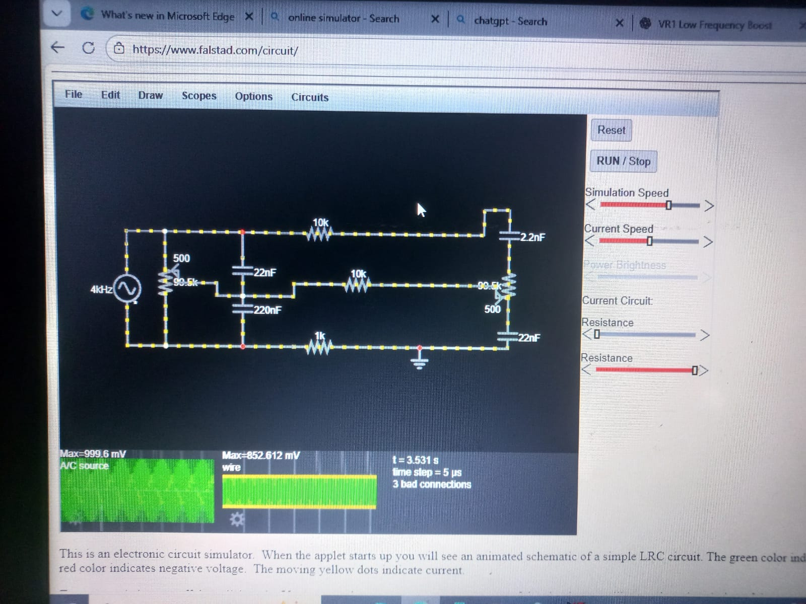
Theory:
Low-frequency control (VR1 + 22 nF & 220 nF)
- When VR1 is at the top position (≈ 0 Ω):
  - The 22 nF capacitor offers very low impedance for high frequencies, so it effectively bypasses them.
  - The 220 nF capacitor allows low-frequency signals to pass toward ground.
  - As a result, low-frequency components are attenuated (cut).
- When VR1 is moved downward (higher resistance):
  - Less low-frequency signal is shunted to ground through the 220 nF capacitor.
  - Therefore, low frequencies are less attenuated and appear boosted at the output.
So, VR1 controls low-frequency cut/boost by changing how much low-frequency signal is diverted to ground.
High-frequency control (VR2 + 2.2 nF & 22 nF)
- When VR2 is at the top position (low resistance):
  - The 2.2 nF capacitor provides a low-impedance path for high frequencies to ground.
  - Hence, high-frequency signals are attenuated (cut).
- When VR2 is moved downward (higher resistance):
  - Less high-frequency signal is shunted to ground through the 2.2 nF capacitor.
  - More high-frequency content reaches the output, so high frequencies are boosted.
So, VR2 controls high-frequency cut/boost.
Output:
